Certificate in DA program

Capstone Projects-8

Project presentation-4

Module : Statistics

1. Introduction to Statistics
2. Methods/Types of Statistics
3. Descriptive Statistics & its measures
4. Inferential Statistics
5. Other Basic concepts
6. Importance of Statistics

Module :Data Analytics using Python

1. Introduction to Python
2. Python Environmental Variables
3. First Python Program
4. Python Identifiers
5. Python variables
6. Standard Data Types
7. SETS
8. Python Basic Operators
9. Decision making
10. Loops
11. Loop Control Statements
12. Python Functions
13. Python Modules
14. Python – Files I/O
15. Python Directory and File Management
16. Python OOPs
17. Python Constructors
18. Inheritance
19. Polymorphism, Encapsulation & Data abstraction
20. Python Multithreaded Programming
21. Data Type conversion

Module: Advanced Python

1. Python Libraries
2. Pandas
3. Numpy
4. Python Data Operations
5. Python Data Cleansing
6. Python Data Processing
7. Python Data Wrangling
8. Python Data Visualization
9. Statistical Analysis of Data using Python

Module: R Programming

1. R: Overview
2. Basic Syntax
3. R: Data Types
4. R- Variables
5. R- Operators
6. R: Decision making
7. Loops
8. apply(), lapply(), sapply(), tapply() in R
9. R – Functions
10. R – Packages
11. R – Data Reshaping
12. R – Data Interfaces
13. R – Data Visualization
14. Statistical analysis using R – Mean, Median and Mode
15. T-test in R: One-Sample and Paired

Module: Predictive Analytics

Case Studies

Data Preprocessing in R

Module: Introduction to machine learning and its algorithms

1. Overview of Machine Learning:
2. Types of Machine Learning algorithms
3. Supervised learning algorithms
4. Unsupervised learning algorithms
5. Ensemble learning techniques
6. The Math of Intelligence
7. Artificial Intelligence vs Machine Learning

Module: Hands-on Machine Learning

1.Use datasets for machine learning algorithms

2.Impliment machine learning algorithms

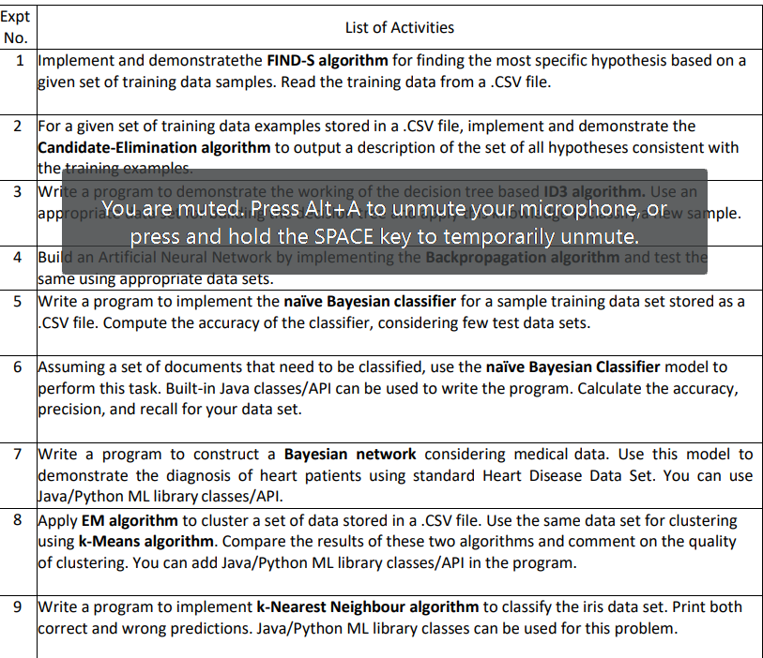

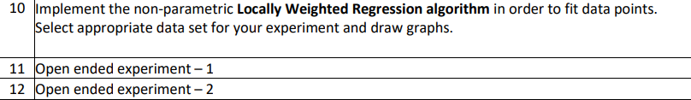

Module: Introduction to machine learning and its algorithms

1. Introduction to Microsoft Excel
2. Ribbons, Tabs and Groups
3. Formatting Cells
4. Modifying a Worksheet
5. Moving through Cells
6. What are Formulas?
7. Sorting Data
8. Filtering Data
9. Splitting Windows and Freeze Panes
10. Charts in MS Excel
11. Pivot Tables
12. VLOOKUP
13. Sparkline in Excel
14. SUMIF function in Excel
15. EXCEL ISBLANK function
16. CSV vs Excel(.xls)- What’s the difference?

Module: VBA for EXCEL

Activity 1: Create a macro

Activity 2: Msg BOX

Activity 3:Workbook and Worksheet Objects

Activity 4: Range Object

Activity 5:Variable

Activity 6:If Then Statement | Else Statement

Activity 7:Loop

Activity 8:

Activity 9: String Manipulation

Activity 10: Date and Time

Activity 11:Events

Activity 12:One-dimensional Array | Two-dimensional Array

Activity 13: Function and Sub

Activity 14:Worksheet function

Application 15: ActiveX Controls

Module: SAS – For Beginners

1. SAS: Overview
2. SAS studio
3. SAS: Program Structure
4. SAS: Data Sets
5. SAS: Variables
6. SAS: Strings
7. SAS: Arrays
8. SAS: Numeric Formats
9. SAS: Operators
10. SAS: Loops
11. SAS: Decision Making
12. SAS: Functions
13. SAS: Input Methods
14. SAS: Macros
15. SAS: Date & Times
16. SAS: Reading Raw Data
17. SAS: Writing Data Sets
18. SAS: Concatenate Data sets
19. SAS: Merge Data Sets
20. SAS: Subsetting Data Sets
21. SAS: Sorting Data Sets
22. SAS: Format Data Sets
23. SAS: SQL
24. SAS: Output Delivery System(ODS)
25. SAS: Simulations
26. SAS: Data Visualization
27. SAS: Enterprise Guide
28. SAS: Visual Analytics
29. JMP

Module: Data Visualization with Tableau

1.Use Tableau as a data visualization platform

2. Design and implement visualizations using tableau.